

Call for Proposals

Sexual Exploitation & Trafficking Awareness Conference

Sept 19th & 20th, 2022

RESET Society of Calgary encourages you to submit a workshop proposal for the 2022 Sexual Exploitation & Trafficking Awareness Conference in Calgary, Alberta, Canada.

**Proposal Submission Deadlines:**

* Sessions & Workshops: April 30th, 2022

**For information email:** [reception@resetcalgary.ca](mailto:reception@resetcalgary.ca)

RESET Society of Calgary is a registered non-profit organization that operates 24 hours a day, year-round. We provide client driven, long-term, comprehensive, wraparound programming and support for women (age 16 and above) who have experienced sexual exploitation and/or sex trafficking. Our programming encompasses extending services to pregnant women and women with children, as well as women experiencing co-occurring issues and challenges such as addiction, trauma, and homelessness.

The 2022 Conference Committee is seeking proposals that reflect leading practice in the field of sexual exploitation and trafficking. In particular, the Committee is seeking proposals related to the following topics:

* **Policy & Regulatory Complexities**
* **Practitioner Training & Toolboxes**
* **Strategic Collaboration**
* **Technology and Social Media**
* **The Housing Spectrum**
* **Trauma Informed Recovery Models**
* **Understanding Indigenous Impacts**
* **Voices of Survivors**
* **Addiction**
* **Brain Development**
* **Community Awareness & Mobilization**
* **Early Intervention**
* **Family & Child Services**
* **Law Enforcement & Justice Services**
* **LGBTQ2 Programming**
* **Mental Health**

With support from: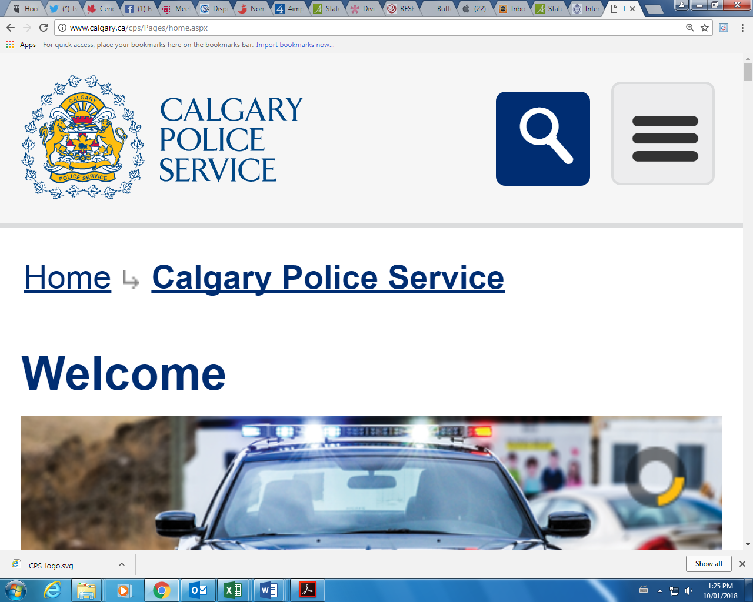

Twitter: @RESETCalgary

Facebook: @RESETCalgary

Instagram: resetcalgary

[reception@resetcalgary.ca](mailto:reception@resetcalgary.ca)

403-237-8477

www.resetcalgary.ca

**Please Like & Share our Social Media**

Twitter: @RESETCalgary

Facebook: @RESETCalgary

Instagram: resetcalgary

**Please Like & Share our Social Media**

Twitter: @RESETCalgary

Facebook: @RESETCalgary

Instagram: resetcalgary

**Please Like & Share our Social Media**

Twitter: @RESETCalgary

Facebook: @RESETCalgary

Instagram: resetcalgary